**IT252 Assignment-6**

NAME: SUYASH CHINTAWAR

ROLL NO.:191IT109

TOPIC: SQL VIEWS

**Q1.(b) Solutions**

1. 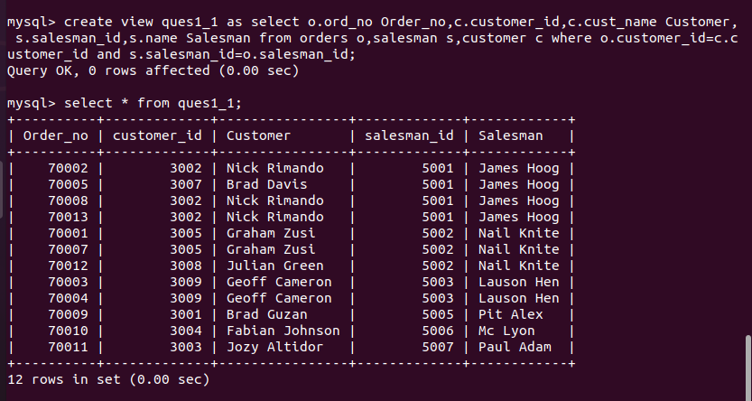 Write a query to create a view that shows for each order the salesman and customer by name.
2. 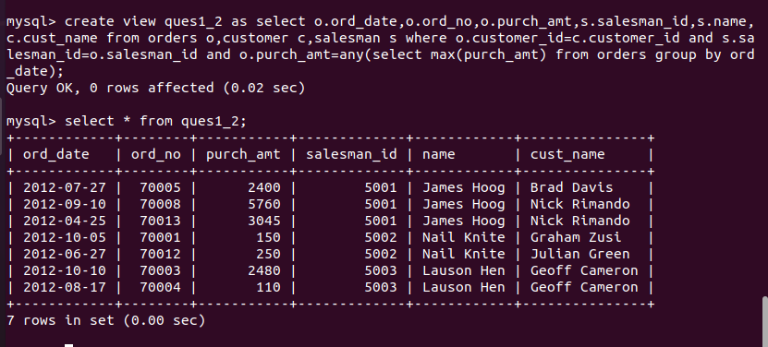Write a query to create a view that finds the salesman who has the customer with the highest order of a day.
3. 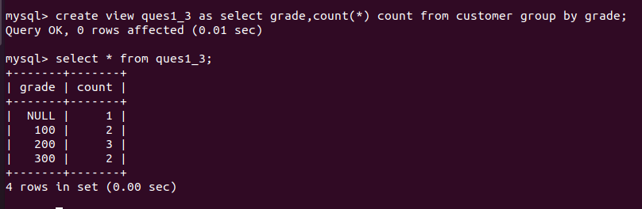Write a query to create a view to getting a count of how many customers we have at each level of a grade.
4. 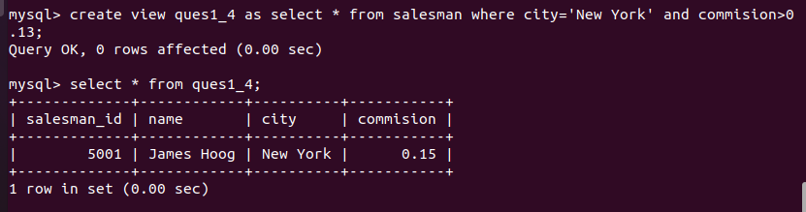Write a query to find the salesmen of the city New York who achieved the commission more than 13%.

NOTE: Ques 2 on next page

**Q2(b) Soultions**

1. 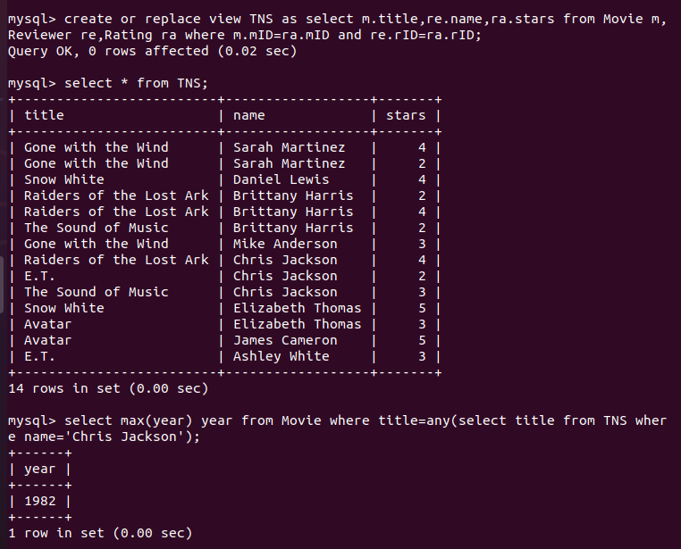Create a view called TNS containing title-name-stars triples, where the movie (title) was reviewed by a reviewer (name) and received the rating (stars). Then referencing only view TNS and table Movie, write a SQL query that returns the latest year of any movie reviewed by Chris Jackson. You may assume movie names are unique.
2. 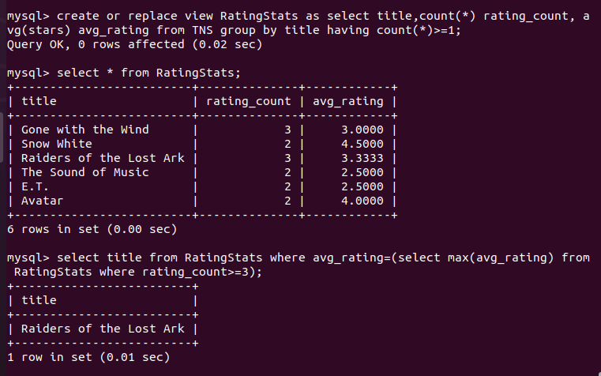Referencing view TNS from Exercise 1 and no other tables, create a view RatingStats containing each movie title that has at least one rating, the number of ratings it received, and its average rating. Then referencing view RatingStats and no other tables, write a SQL query to find the title of the highest-average-rating movie with at least three ratings.
3. 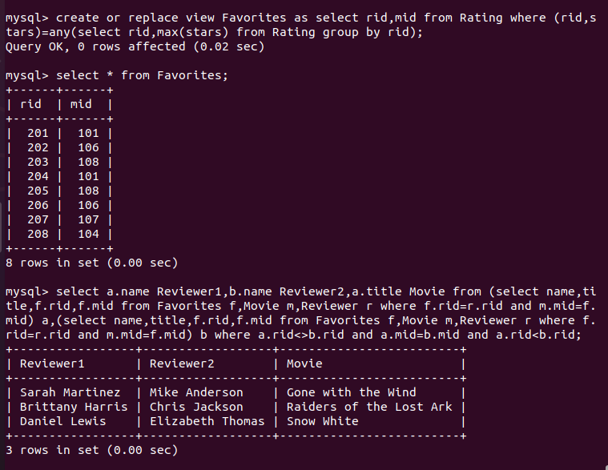Create a view Favorites containing rID-mID pairs, where the reviewer with rID gave the movie with mID the highest rating he or she gave any movie. Then referencing only view Favorites and tables Movie and Reviewer, write a SQL query to return reviewer-reviewer-movie triples where the two (different) reviewers have the movie as their favorite. Return each pair once, i.e., don’t return a pair and its inverse.

THANK YOU